Mihai Dan

CS275-001

Assignment 4

11/2/14

**Chapter 6:**

16.

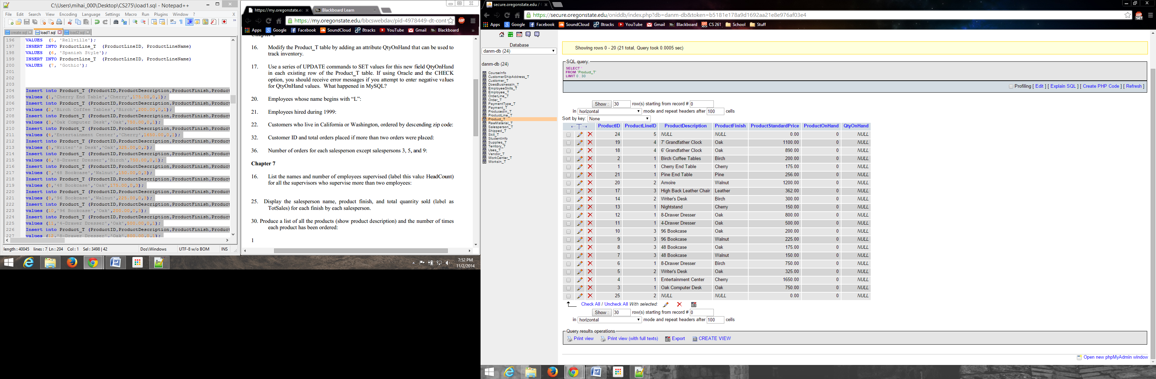

17.

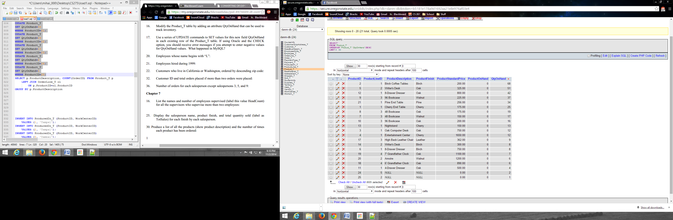

20. 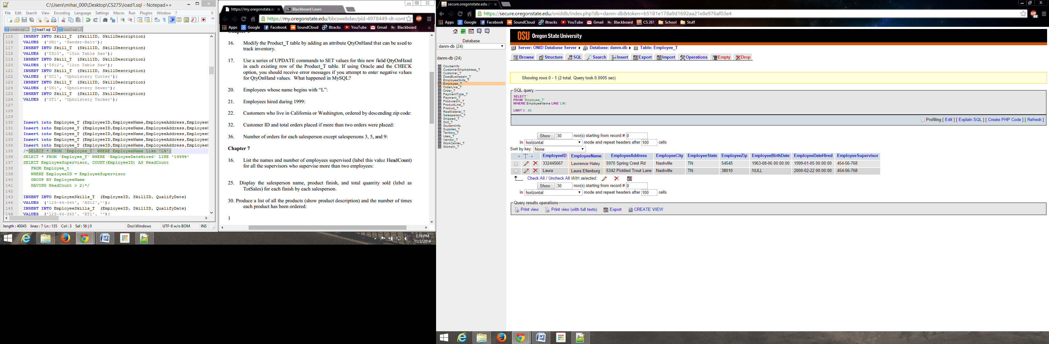

21.

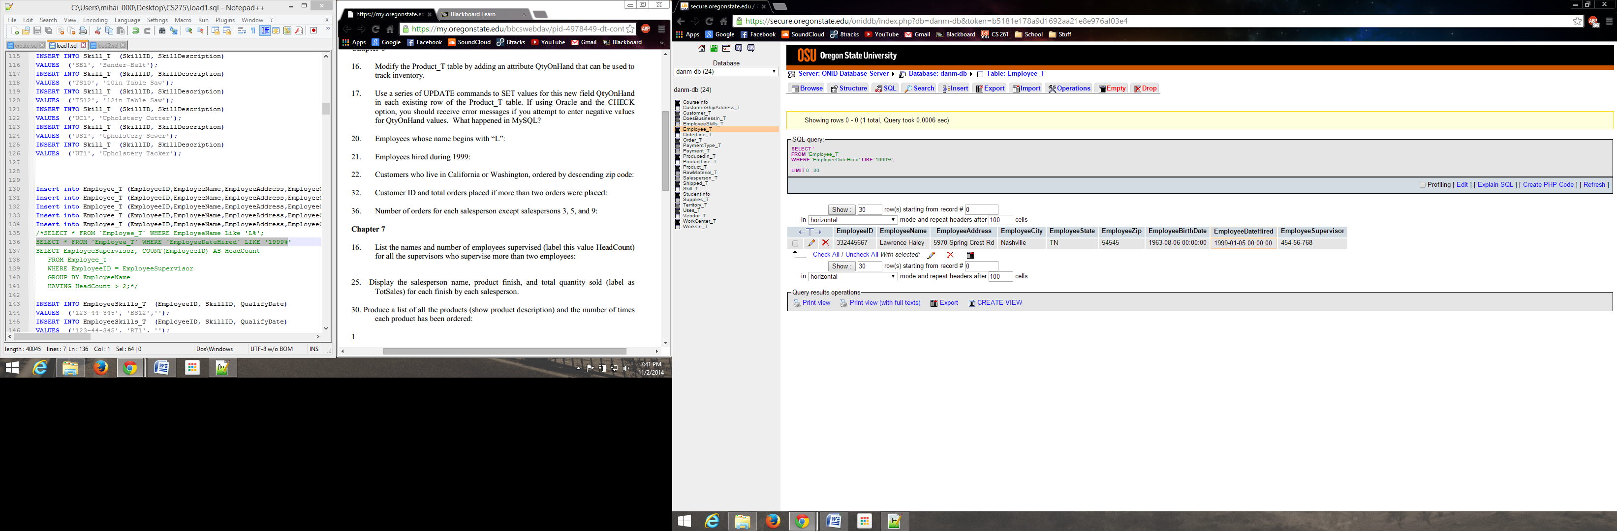

22.

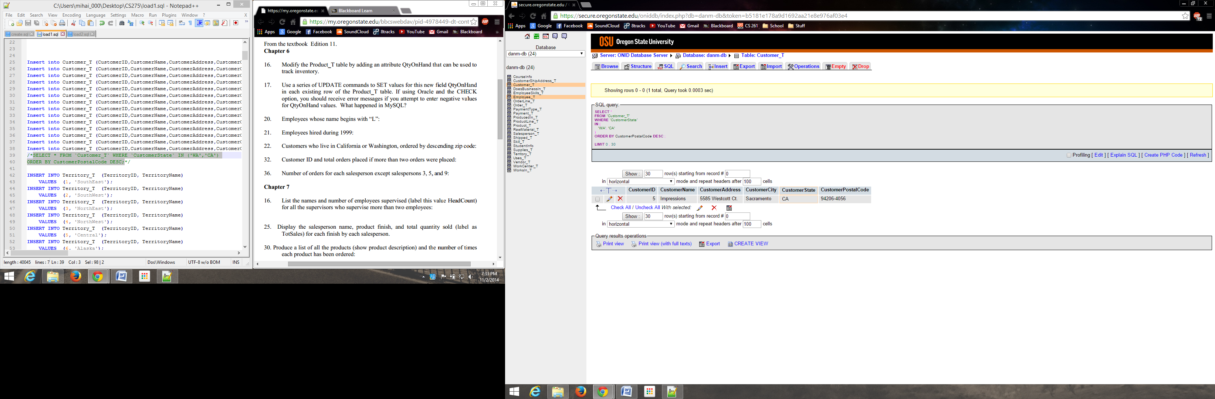

32.

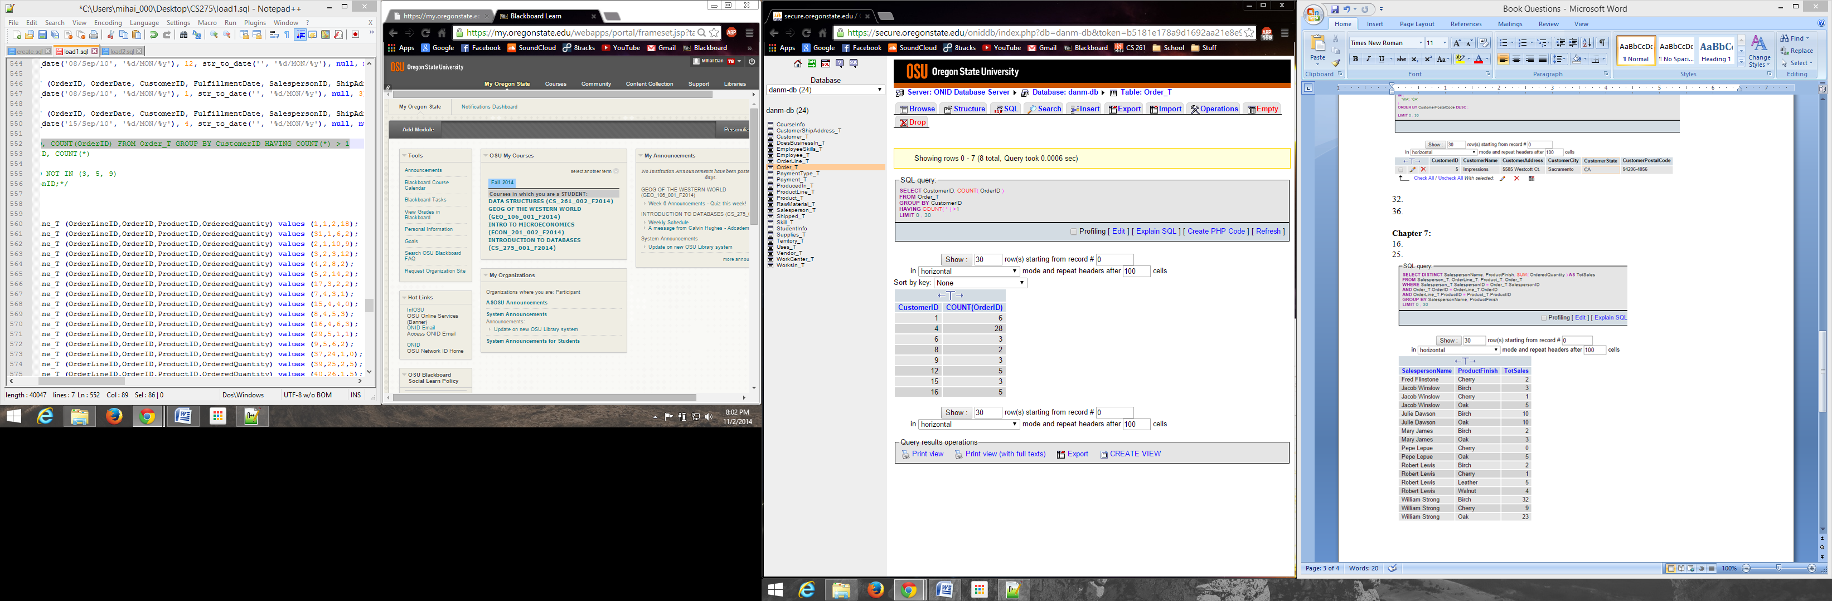

36.

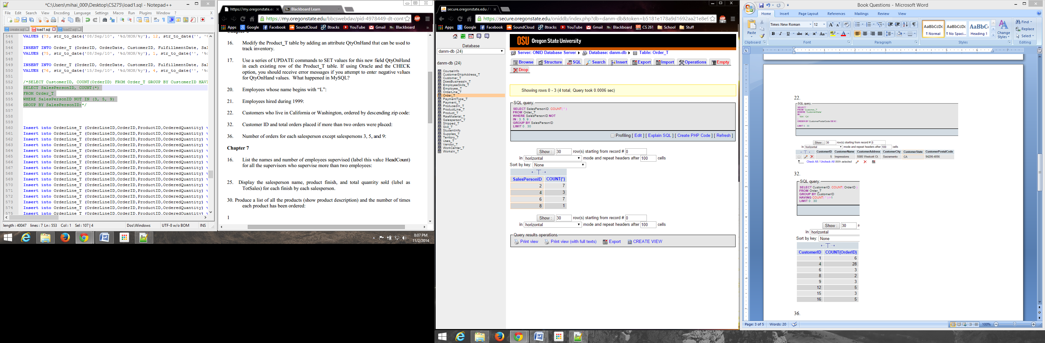

**Chapter 7:**

16.

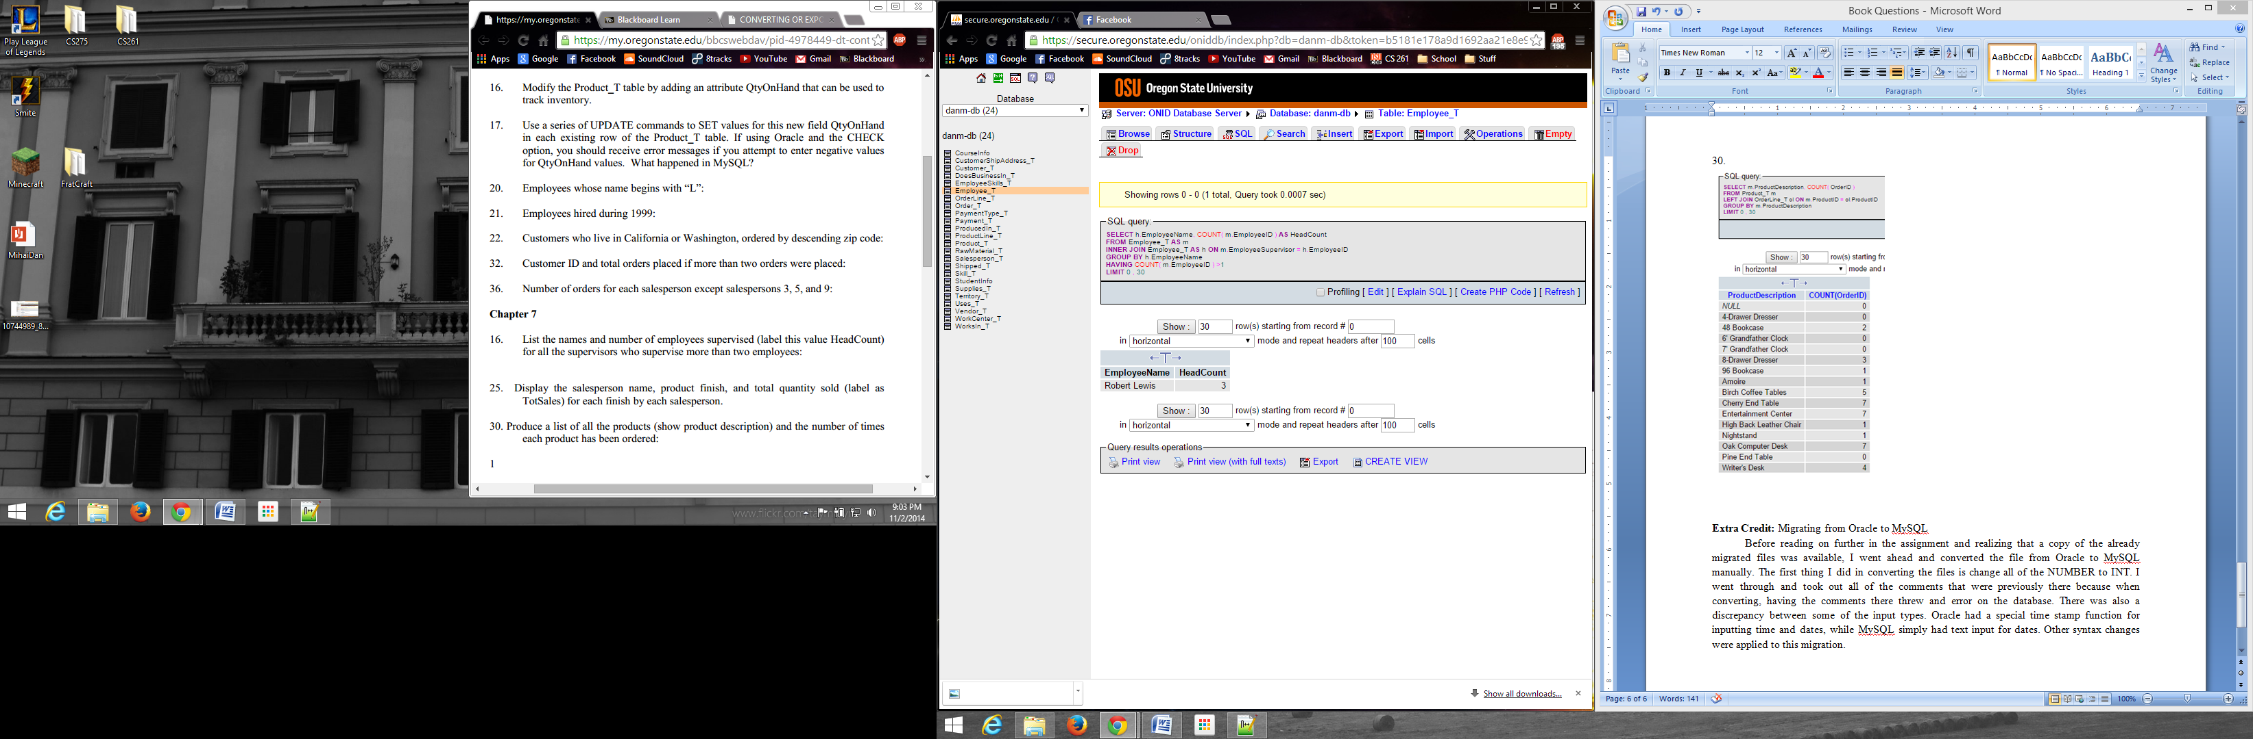

25.

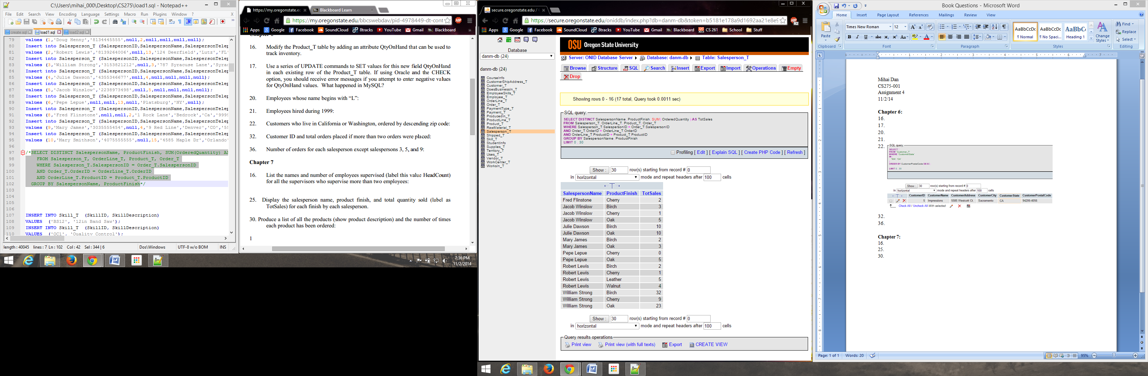

30.

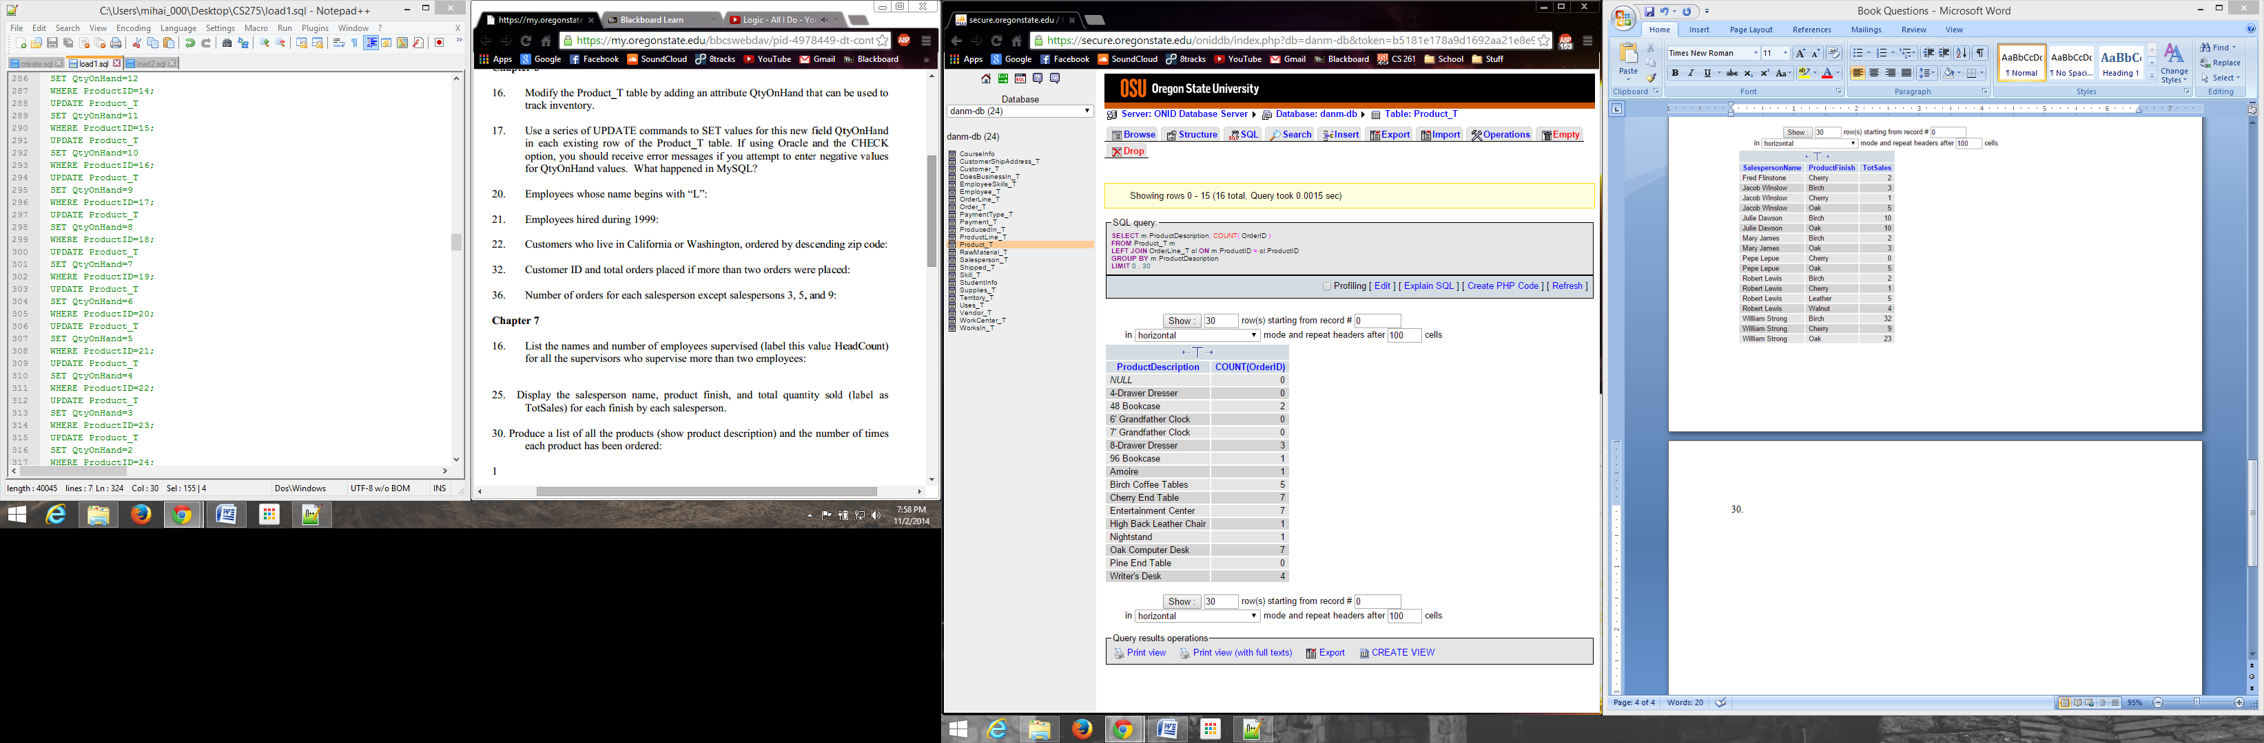

**Extra Credit:** Migrating from Oracle to MySQL

Before reading on further in the assignment and realizing that a copy of the already migrated files was available, I went ahead and converted the file from Oracle to MySQL manually. The first thing I did in converting the files is change all of the NUMBER to INT. I went through and took out all of the comments that were previously there because when converting, having the comments there threw and error on the database. There was also a discrepancy between some of the input types. Oracle had a special time stamp function for inputting time and dates, while MySQL simply had text input for dates. Other syntax changes were applied to this migration.